Data Story

Unitywater - Digital Water Meter data

[https://www.data.qld.gov.au/dataset/digital-water-meter-dataset-explanation](https://www.data.qld.gov.au/dataset/digital-water-meter-dataset-explanation/resource/9fcbd9cf-ee34-4e85-a44f-8afdebdb5237)

Using Digital water meter data July 2022 we calculated and analysed the daily water usage of resident with ID:61221417 for the month of July.

Example of a household usage over a month 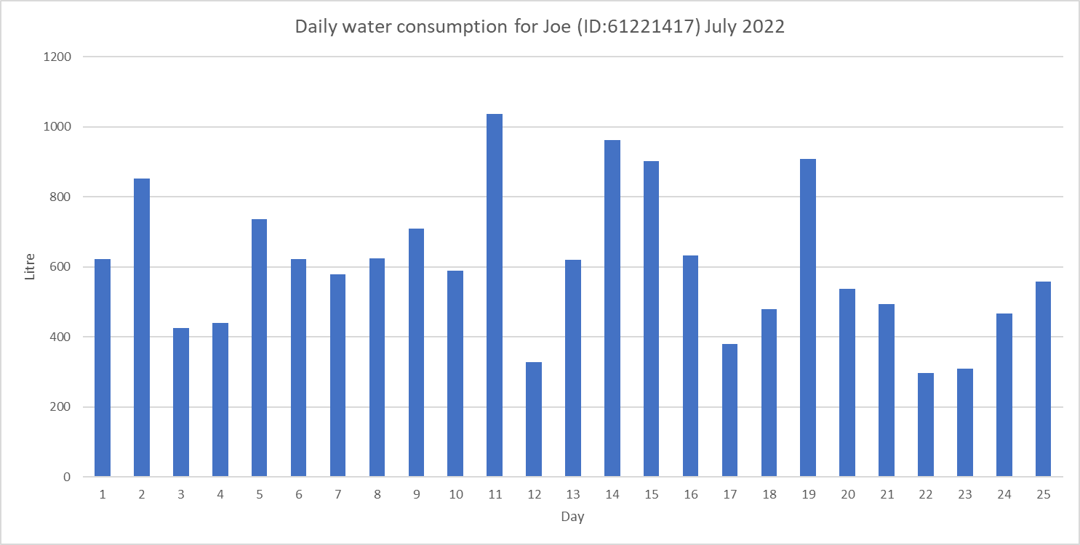

Example of a household usage over a month using Aqua

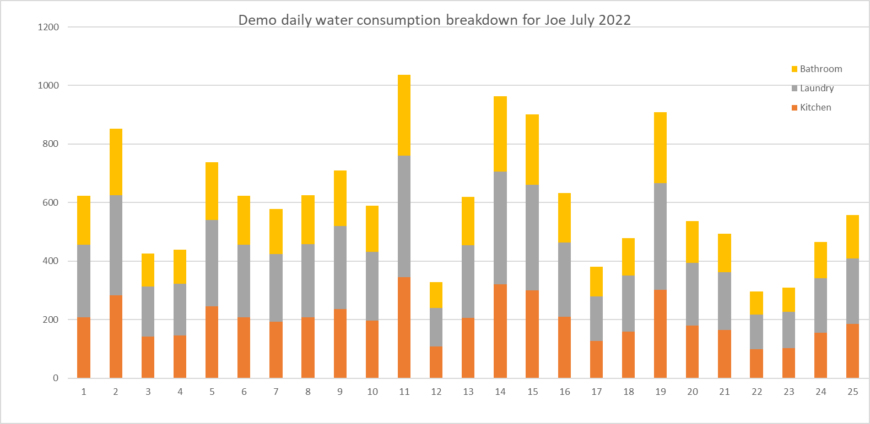

2016 - 2021: Annual report operations 5 year comparison

<https://data.sa.gov.au/data/dataset/annual-report-operations-4-year-comparison/resource/8d6d4b68-cacd-46ea-afa4-81b2bd45395a>

Using the Annual report we analysed the water consumption of the Australian population which shows a gradual increase in the water consumption over the past 5 years.

